This Forward Plan was published on 14 August 2019. It will be published and updated on a monthly basis.

Key Decision | Decision Taker | Date to be taken | Ref.  No. | Consultees and method | Documents to be submitted to the decision taker in relation to the matter | Lead Officer to make representations to / and the date to be submitted by
To approve the purchase of temporary accommodation. | Cabinet | 12 September 2019 | 86 | N/A | TBC | Joe Powell  Head of Service Housing and Community  Tel: 01424 787530  joe.powell@rother.gov.uk

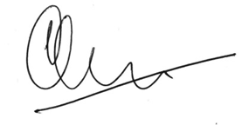
Signed Councillor D.B. Oliver
Leader of the Council, 15 August 2019

A Key Decision is one which is likely to result in significant expenditure or savings (in excess of £100,000) or to have significant effects on those living or working in an area comprising two or more wards.
This information will be updated as the documents are identified.

