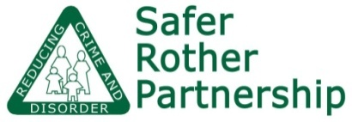

Community Trigger request form

You can submit a Community Trigger request using this form if you have reported three separate anti-social behaviour or hate incidents in the last six months and no action has been taken.

Your Contact Details
Name

Address

Postcode

Telephone

Mobile

Email

Are you | An owner/occupier  In private rented accommodation  in social housing
If you are in social housing who is the housing provider?

Preferred method of contact | Telephone  Mobile  Email

Incident details

Incident one
Date

What happened?

Where did it take place?

How has it affected you?

Who did you report it to?

Were you given a reference number or name of who would be dealing with it? Please provide these details if you can remember…
What response did you get to this first report?

Incident two
Date

What happened?

Where did it take place?

How has it affected you?

Who did you report it to?

Were you given a reference number or name of who would be dealing with it? Please provide these details if you can remember…
What response did you get to this first report?

Incident three
Date

What happened?

Where did it take place?

How has it affected you?

Who did you report it to?

Were you given a reference number or name of who would be dealing with it? Please provide these details if you can remember…
What response did you get to this first report?

Additional information

Please use the space below to provide any additional information which you feel is relevant

Please e-mail your form to envhealth@rother.gov.uk

OFFICE USE ONLY

Date form received
Lead agency
Have the Trigger criteria been met? | Minimum of 3 complaints in 6 months  No action been taken  YES  NO
If NO, confirmation that lead agency has made contact with the complainant and name of person making that contact.
Date of contact
If YES, date of ASBRAC review.
Confirmation that action plan agreed and lead agency has made contact with the complainant and name of person making the contact.
Date of contact

